14-06-2026
Bilal Hamdani
Follow up confirm identity using public identifiers
FRS2526-2.2

3.1.3 Follow-up: new leads from ZebrainZion and zenmama1970
Case FRS2526-2.2 - SOCMINT investigation - username silentnomore24
Date: 14-06-2026 Analyst: Bilal Hamdani
After the 3.1.4 analysis, two leads were taken forward for more searching: the name ZebrainZion (the display name on the Snapchat account) and the account zenmama1970 (the only follower of the TikTok account). This document covers what was found for each.

Lead 1: ZebrainZion
A search for "Zebrain Zion" on IDCrawl returned several Instagram profiles using that name or a close variant.
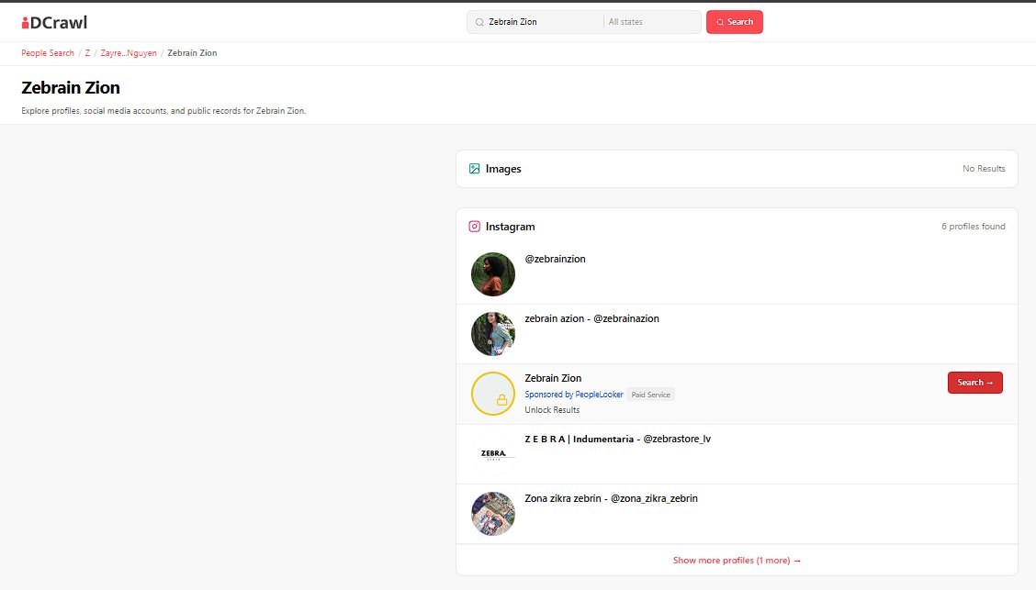
IDCrawl search results for "Zebrain Zion".
Profile | Notes
@zebrainzion (Instagram) | Profile picture shows a person with dark curly hair against a green/forest background. This looks similar to the Snapchat Bitmoji (ZebrainZion, silentnomore24), which also shows a person of colour with dark curly hair in an autumn forest setting.
The @zebrainzion profile (13 posts, 22 followers, 48 following) has a bio that reads “No more silence - Voice raised for the wild and wounded”. Our received information was the username silentnomore24.
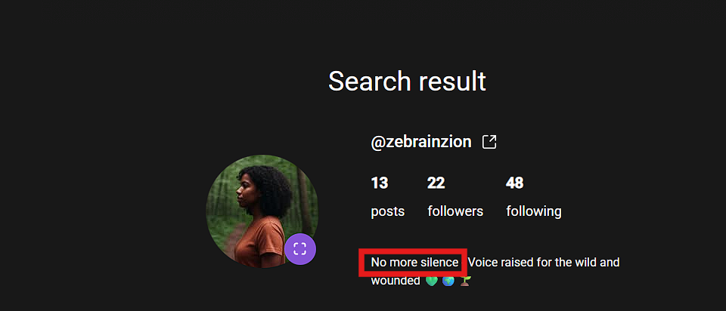
@zebrainzion Instagram profile: 13 posts, 22 followers, 48 following, bio “No more silence - Voice raised for the wild and wounded.”
Looking at the posts on this account, this person is active around climate and environmental awareness, which fits the profile of an activist. Most of the posts, apart from the food photo, appear to be AI-generated, and the profile picture itself also looks AI-generated. One post (the food photo) mentions launching a Discord server to talk about food, which is a separate lead to follow up on in a later step. Posting started on 4 June 2025, with no posts on 7 June 2025, and continued up to 13 June.
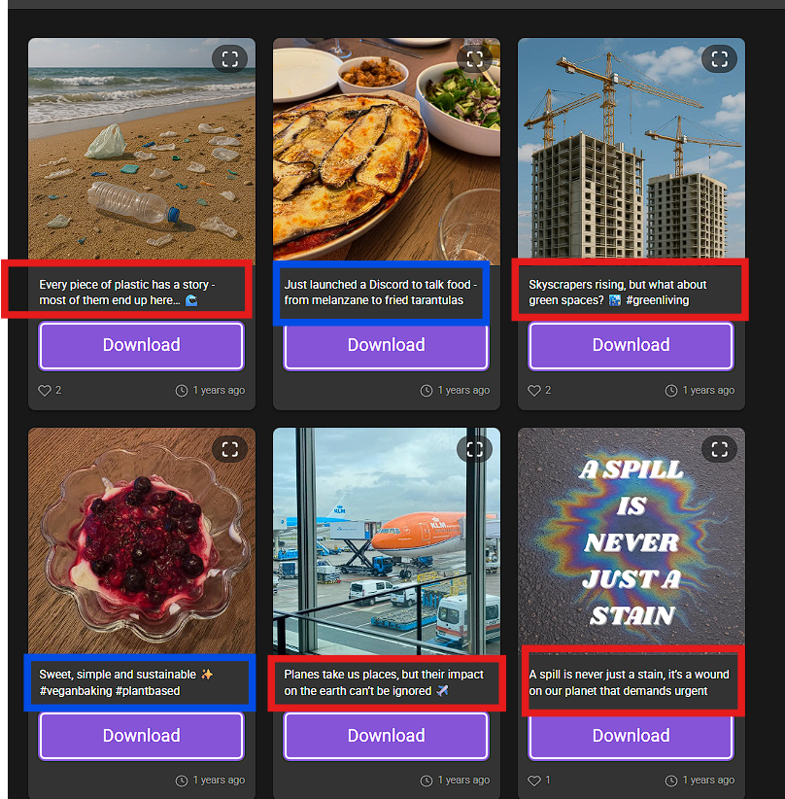
Posts on @zebrainzion: environmental/climate themes (plastic pollution, green spaces, planes and emissions), a food post announcing a Discord server, and an AI-generated “spill” graphic.
On this Instagram account, zebrainzion follows a person called tobiasdander, and tobiasdander follows zebrainzion back. This could mean they know each other. No other accounts that zebrainzion follows appear to follow back.

Lead 2: zenmama1970
zenmama1970 is the only follower of the TikTok account SILENTNOMOREGRASSROOTS (@silentnomore24). The display name shown was "CL", with an activism-themed profile picture using an Alberta-shaped "no space for hate" logo, 285 followers and 3740 following.
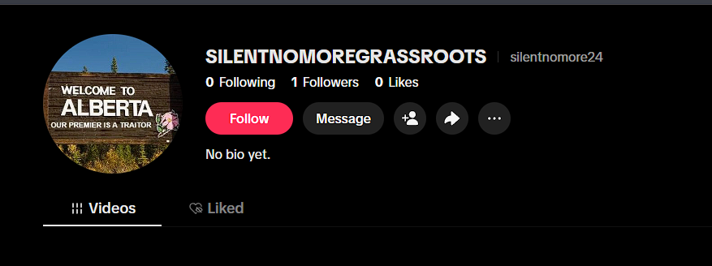
TikTok account SILENTNOMOREGRASSROOTS (@silentnomore24), 1 follower: zenmama1970.
A search for zenmama1970 on IDCrawl shows the username is used as "C L Zenmama1970" across platforms. The letters "C L" likely stand for this person's initials.
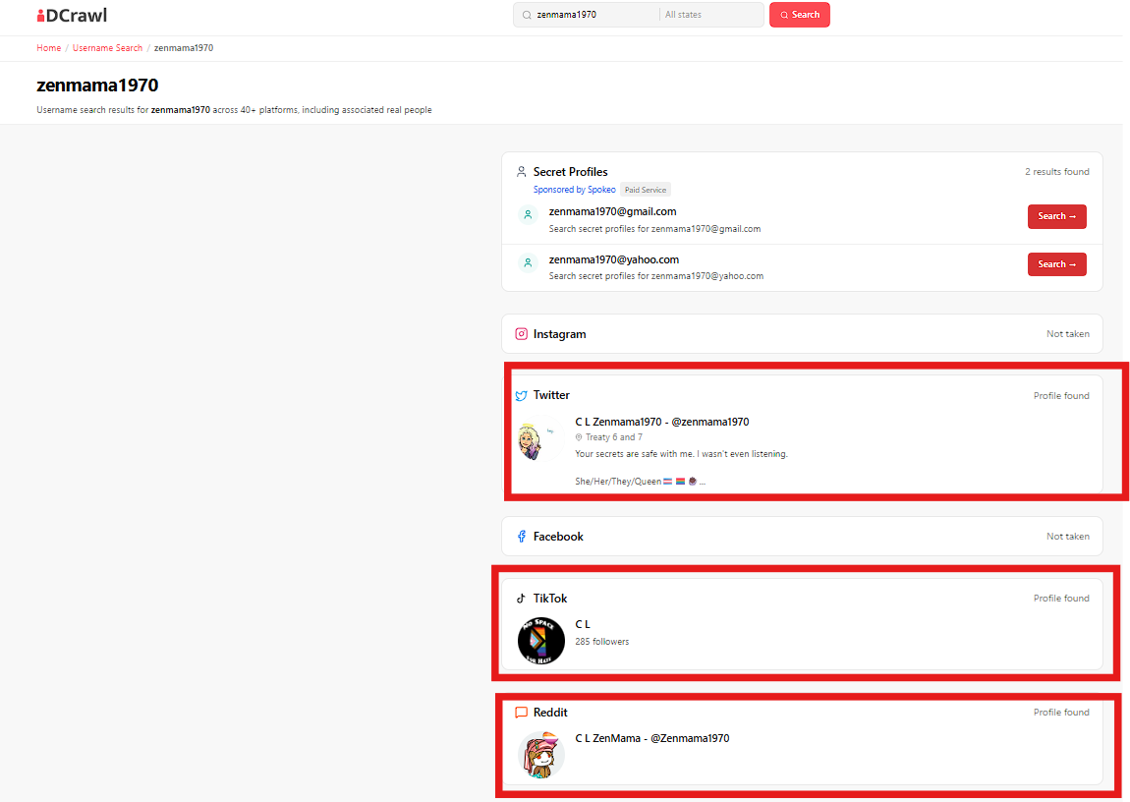
IDCrawl results for zenmama1970: profiles found on Twitter, TikTok, and Reddit, all using the name "C L Zenmama1970" or "C L ZenMama".
The Twitter profile for C L Zenmama1970 (@zenmama1970) shows the location "Treaty 6 and 7", which refers to Indigenous treaty territories that cover most of Alberta. The bio reads “Your secrets are safe with me. I wasn't even listening.”, with pronouns She/Her/They/Queen. The account was joined in February 2024 and has 80 following, 4 followers.
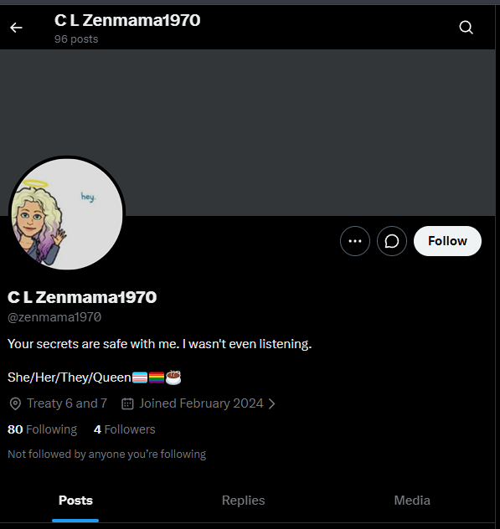
Twitter profile C L Zenmama1970 (@zenmama1970): location “Treaty 6 and 7”, joined February 2024.
The Twitter account settings page confirms the account is based in Canada, with 1 username change recorded in February 2024, and connected via a Canada Android app.
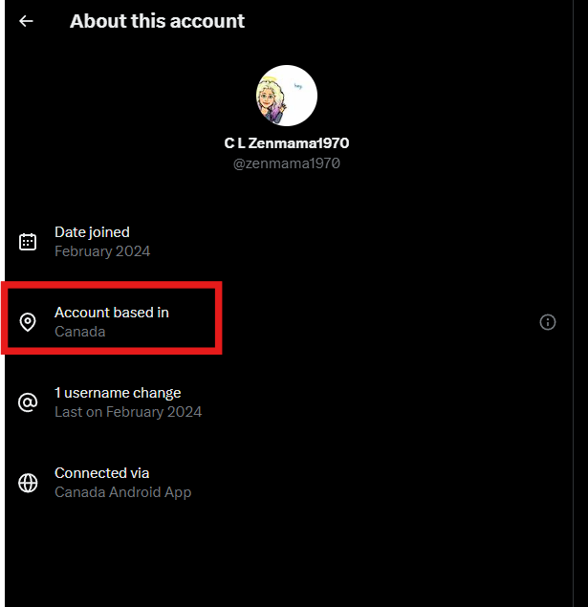
Twitter account info for @zenmama1970: account based in Canada, connected via Canada Android App.
On 11 April 2024, @zenmama1970 replied directly to Danielle Smith, the Premier of Alberta (@ABDanielleSmith), commenting on a post about an Alberta power grid alert. This is a direct, public interaction with the Alberta premier, and matches the message on the TikTok profile picture (“Welcome to Alberta, our premier is a traitor”).
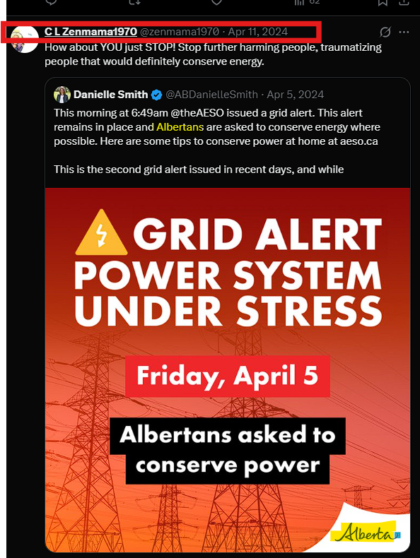
@zenmama1970 replying to Alberta premier Danielle Smith (@ABDanielleSmith) about a power grid alert in Alberta, April 2024.
The TikTok account is private, so it was not possible to see who zenmama1970 follows or is followed by there. A Twitter check did not connect zenmama1970 to zebrainzion: the topics of their posts are different, which suggests these are not the same person.
A Reddit account under u/Zenmama1970 (display name "C L ZenMama") shows a comment giving supportive, parent-like advice to someone asking whether they could stay with friends.
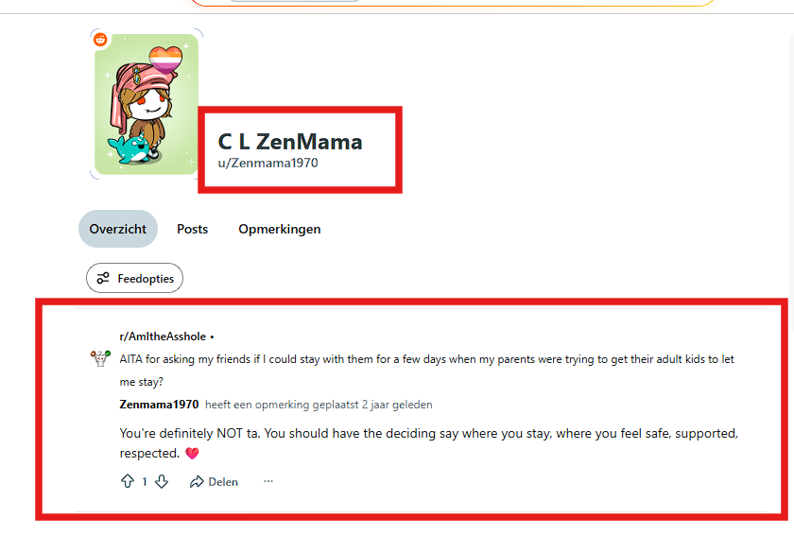
Reddit comment from u/Zenmama1970 giving supportive advice in r/AmItheAsshole.
A Tripadvisor account called "Quinn & Mom" (@Zenmama1970) posted one review, of the Red Bird Diner, in September 2021. "Quinn" may be this person's child. The Red Bird Diner is located at 220 Arena Ave, Trochu, Alberta, Canada, which is the same general area (Alberta) referenced by the TikTok account and the Twitter location "Treaty 6 and 7".
Combined with the direct reply to the Alberta premier, this gives a consistent picture that the TikTok account SILENTNOMOREGRASSROOTS (@silentnomore24) and zenmama1970 are both connected to Alberta, Canada.
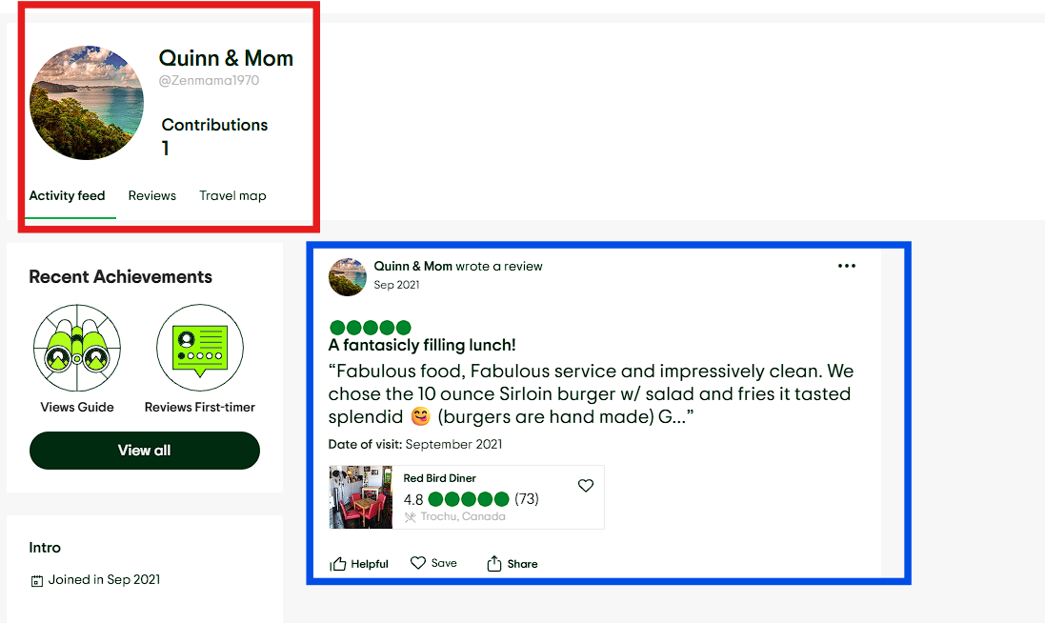
Tripadvisor account "Quinn & Mom" (@Zenmama1970), review of Red Bird Diner, Trochu, Alberta, Canada, September 2021.
It is worth noting that an account being "based in Canada" on Twitter can be changed using a VPN, so this is not a fully reliable signal on its own. However, combined with the Treaty 6 and 7 location, the reply to the Alberta premier, and the Red Bird Diner review in Trochu, Alberta, the overall picture for zenmama1970 points consistently to Alberta, Canada.

Conclusion
Of the two leads, @zebrainzion is the more promising one for identifying the person behind silentnomore24, because of the visual similarity to the Snapchat Bitmoji. The Discord server mentioned in one of zebrainzion's posts is a separate lead to look into next. The follow connection with tobiasdander is also worth checking further.
zenmama1970 did not lead to a new connection with the silentnomore24 accounts directly, since the Twitter content does not match zebrainzion's content. However, zenmama1970 gives a consistent and fairly strong location signal: Alberta, Canada, supported by the Treaty 6 and 7 location, the Red Bird Diner review in Trochu, and the direct reply to the Alberta premier. This matches the message on the TikTok profile picture and supports treating Alberta, Canada as the most likely region connected to the TikTok account SILENTNOMOREGRASSROOTS. Both accounts SILENTNOMOREGRASSROOTS and zenmama1970 can be from the same person.

